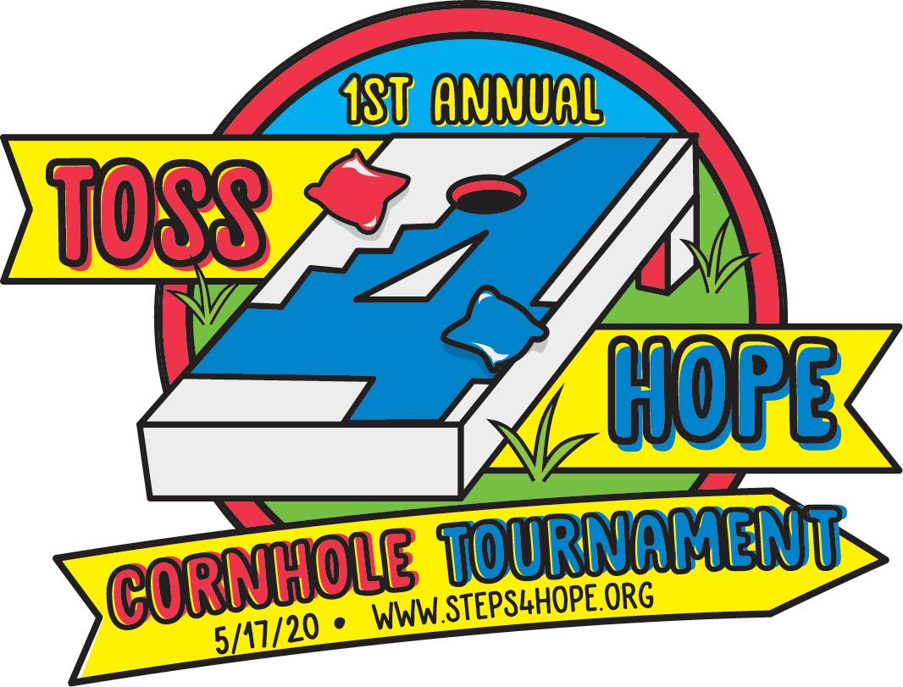

2020 Toss4hope Sponsorship Opportunities

$1,000 - Golden Sombrero Level-Presenting Sponsor
(Golden Sombrero: when a player makes all 4 bags into the hole during one round)
- 2 team entries
- Company logo or family name on 1 set of custom boards
- “Yours to keep” personalized cornhole board set
- Recognition as Golden Sombrero presenting sponsor at the event
- Website and social media acknowledgement with company link
- Prime logo/name placement on event signage

$500 - Swisher Level
(Swisher: when a bag is thrown directly into the hole without touching the board)
- 1 team entry
- Company logo or family name on one set of custom boards
- Website and social media acknowledgement with company link
- Prominent logo/name placement on event signage

$250 - Leprechaun level
(Leprechaun: when a player lands 4 bags on the board without getting any into the hole)
- 1 team entry
- Website and social media acknowledgment with company link
- Logo/name on event signage

$100 - Ace Level
(Ace: when a bag lands on the board)
- Website and social media acknowledgment with company link
- Logo/name on event signage

____Yes, I want to be a Toss4Hope Sponsor!

___Golden Sombrero ___Swisher ___Leprechaun ___Ace

Business/ Family Name: _________________________ Contact Person:_________________________________

Address: _______________________________________________________________________________________________

Phone Number: ______________________________ Email address: _______________________________________

Sponsorship deadline- May 1, 2020.
Please make checks payable to Steps4Hope and return to 9 Fox Ridge Drive, Malvern, Pa. 19355.
Submit hi-res pdf logo for custom cornhole wraps to kellyprevost@hotmail.com

