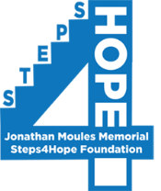

2022 Steps4Hope Sponsorship Levels

$1,000 – Platinum Presenting Sponsor
- Special recognition during awards ceremony as Presenting Sponsor
- Prominent logo placement on T-shirt
- Recognition in all printed collateral, as well as on event signage
- Visibility in social media through Sponsorship Updates
- 4 complimentary race entries

$500 – Gold Sponsor
- Featured logo placement on T-shirt
- Recognition in thank-you event signage at your choice of Registration Table, Hydration Station, or Mile Maker
- Visibility in social media recognition through Sponsorship Updates
- 2 complimentary race entries

$250 – Silver Sponsor
- Logo on T-shirt
- Logo on event signage
- Visibility in social media recognition through Sponsorship Updates
- 1 complimentary race entry

$100 – Bronze Sponsorship
- Name printed on T-shirt
- Visibility in social media recognition through Sponsorship Updates
- Name on event signage

___Yes, I want to be a Steps4Hope Sponsor!

_____ Platinum Presenting ______Gold _____Silver _______Bronze
Business Name: _________________________________________________________________

Address:_______________________________________________________________________

Phone Number:_________________________________________________________________

Contact Person:_________________________________________________________________

Email address:___________________________________________________________________

Sponsorship Deadline- September 16, 2022 - Please make checks payable to Steps4Hope
Return to Pam Moules, 9 Fox Ridge Drive, Malvern, PA 19355
Submit company logo for T-shirts (hi-res pdf) to jmsteps4hope@gmail.com. Thank you!!!!
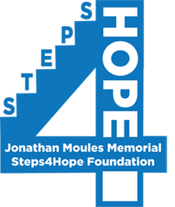

Did You Know???

- Steps4Hope was created to honor the life, legacy, and memory of Jonathan Moules, our beloved 22-year old son, who lost his battle with the disease of addiction in January 2014. Our goal, through Steps4Hope, is to educate, support, and give hope to those who are facing this illness or who have lost family and loved ones to its ravages.

- On average, 275 people daily are lost to accidental overdose.

- In 2021, drug overdose deaths surpassed 100,000 for the first time.

- Pennsylvania had the eighth highest drug overdose mortality rate in the United States with 5,410 deaths reported.

- Drug overdose and fentanyl poisoning are now the leading cause of death under the age of 50 in the United States.

Become part of the solution, by participating in our annual event. Through the programs we sponsor from your generous contributions, we aim to:

- Give hope and provide financial resources to those battling with the disease of addiction
- Educate the public about the true crisis of substance use disorder, as well as empower youth to avoid falling prey to its hold
- Provide compassionate care and support to parents and siblings who have lost loved ones to this disease.

Steps4Hope is registered with CharitySmith National Society of Memorial Funds (EIN# 87-0636433). Please check with your Human Resources department to see if your gift is eligible to be matched. Thank you!

